OPIN PILOT CONCEPT
  - Youth Horizon, Georgia
October – February 2020

The Context

The youth e-participation project will be carried out by Youth Horizon in the seaside town of Kobuleti which is an administrative center of the Kobuleti municipality. Located in the northwest of the country on the eastern coast of the Black Sea, the residents of the municipality largely depend on tourism as a source of their income. The majority of the younger generation after graduating their secondary studies either choose to pursue academic studies in Batumi or leave for Tbilisi. The local self-government, which comprises of the Municipality Local Council and the City Hall, lacks youth-oriented policies and programmes to address the needs of the local youth.
Georgia as a signatory country of The Revised European Charter on the Participation of Young People in Local and Regional Life is encouraged to promote youth participation at the local level and adopt sectoral policies in this direction. The e-participation project is built on the advocacy of the Charter at the municipal level. The Kobuleti municipality has already allocated 250,000 GEL for public budgeting purposes, the implementation of which has been interrupted by the Covid 19 outbreak. With the support of the Youth Horizons team and OPIN tools, by the end of the annual budgeting the municipality will be presented with the policy recommendations for 2021.
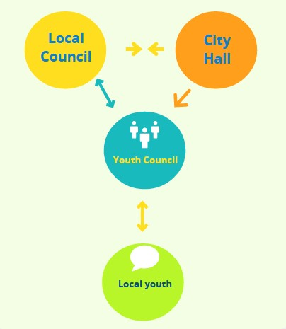
It is envisioned by the project that the OPIN platform will be used by the Youth Horizon’s local youth council as a loudspeaker to convey the interests of Kobuletian youth to the local municipality council and the city hall. The youth council is placed in the center of the Y-shaped (or a slingshot if you will) communication process as shown in the figure 1.
The youth council to be formed with the participatory project will unite 16 young people aged between 14-29 with 5 thematic committees in the following areas:
Figure 1: e-PARTICIPATION MODEL
- Sports, leisure time and healthcare
- Employment and combating unemployment
- Youth living in rural areas
- Human rights
- Education and youth information services

Participatory Process

https://en.wikipedia.org/wiki/Kobuleti

